## University Institute of Information Technology

**Faculty of Computing**

|  |  |  |  |
| --- | --- | --- | --- |
| **Course Code:** | CS-432 | **Subject:** | MPL |
| **Lab Manuals** | | **Class/Lab Instructor:** |  |

**Learning Objective:**

# -------------------- LAB 02 --------------------

**Classes and Types of Constructor**

### Discuss the data types in Java.

1. Operator in Java.

### Conditional Statement

1. Loops (While, For, Do While)

### Switch Statement

1. Exercises

# Data types are divided into two groups:

* **Primitive data types** - includes byte, short, int, long, float, double, boolean and char
* **Non-primitive data types** - such as String, Arrays and Classes (you will learn more about these in a later chapter)

**Example 1 #** Integer in Java

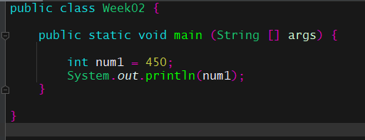

**Example 2 #** Boolean data type

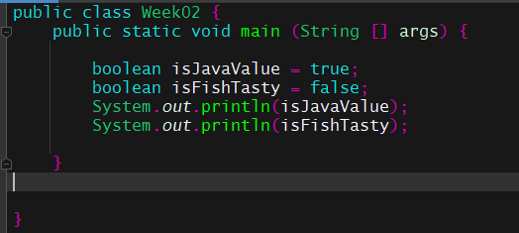

**Example 3 #** Characters data type

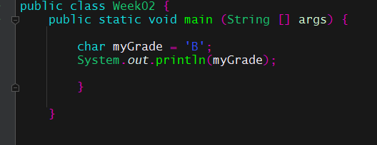

**Example 4 #** Operator in Java

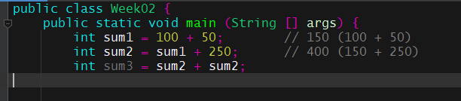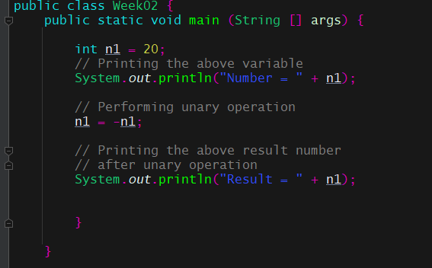

**Example 5 #** Unary Operator

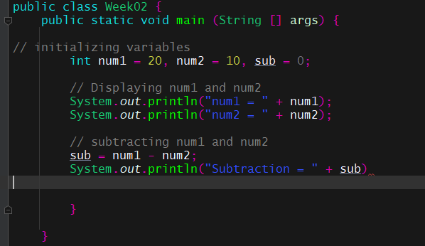

**Example 6 #** Arithmetic Operator

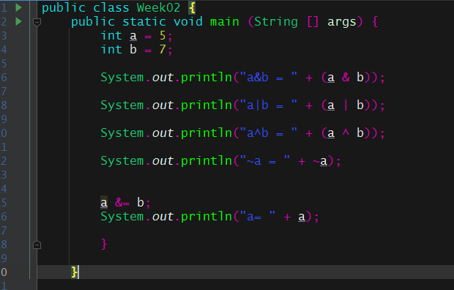

**Example 7 #** Bitwise Operators

**Example 8 #** Assignment Operator

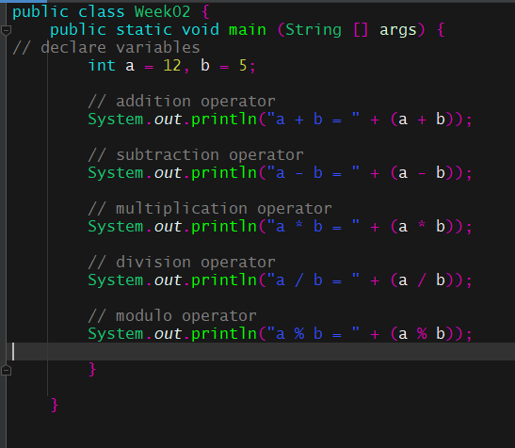

# Java If-else Statement:

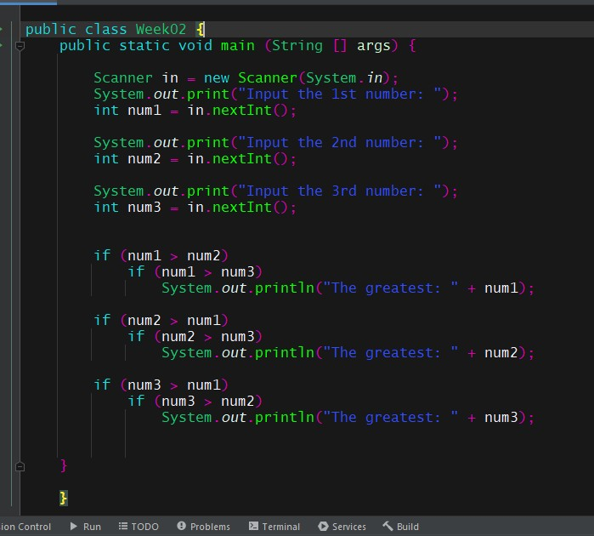

### The if-else statement helps you to run a specific block of a program if the condition is true or else, it will check other conditions. It is used to control the flow or to determine the rules in a program.

**Example 9 #** Take three numbers from the user and print the greatest number

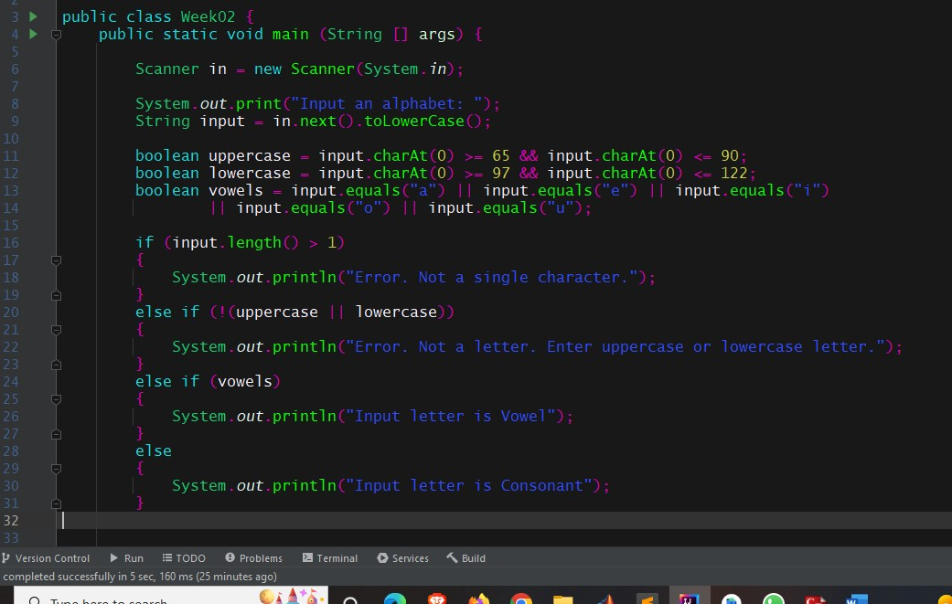

**Example 10 #** Write a Java program that takes the user to provide a single character from the alphabet. Print Vowel of Consonant, depending on the user input. If the user input is not a letter (between a and z or A and Z), or is a string of length > 1, print an error message.

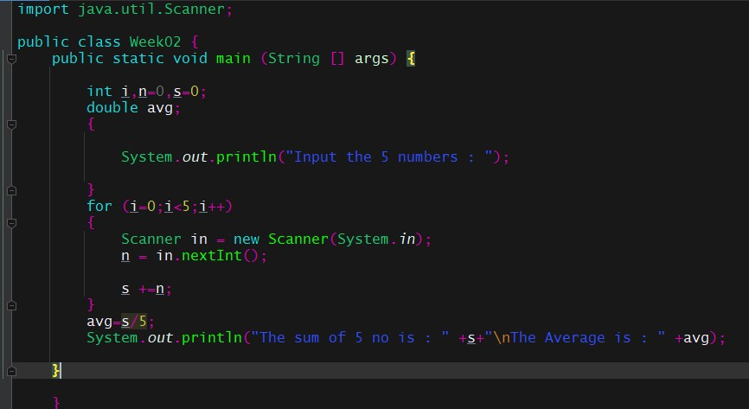

**Loops:** while, for, Do while loop in Java

Loops in Java is **a feature used to execute a particular part of the program repeatedly if a given condition evaluates to be true**.

**Example 11 #** Write a program in Java to input 5 numbers from keyboard and find their sum and average.

**Example 12 #** Repeat example 10 with While Loop

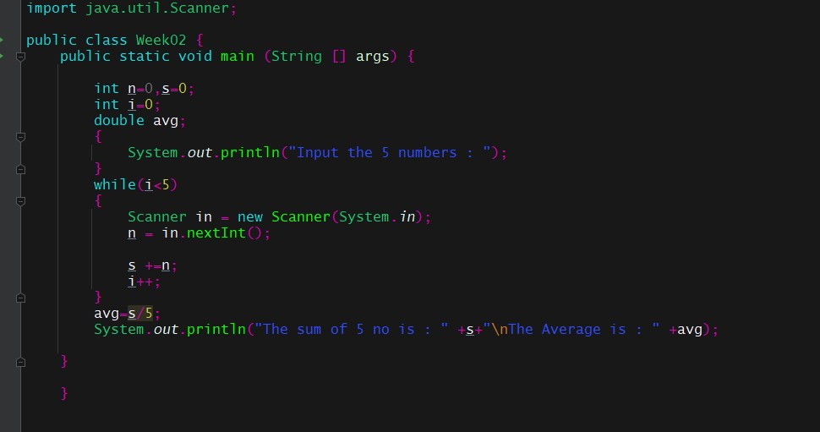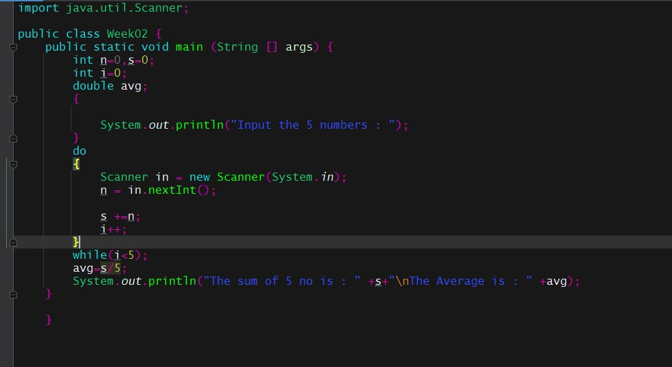

**Example 13 #** Repeat example 10 with Do While Loop

# Switch Statement:

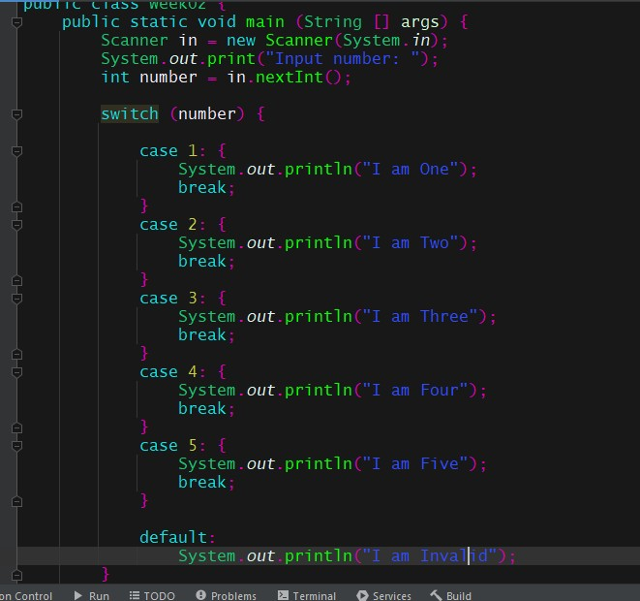

### The switch statement or switch case in java is **a multi-way branch statement**. Based on the value of the expression given, different parts of code can be executed quickly. The given expression can be of a primitive data type such as int, char, short, byte, and char.

**Example 14 #** Switch Statement

**Lab Task(s)**

1. Write a Java program that reads a number in inches, converts it to meters.
   * One inch is 0.0254 meter
2. Write a Java program to get a number from the user and print whether it is positive or negative.
3. Write a Java program that takes a year from user and print whether that year is a leap year or not.
4. Write a Java program that keeps a number from the user and generates an integer between 1 and 7 and displays the name of the weekday.

### Using Switch Statement

1. Write a program in Java to display the multiplication table of a given integer.
   * Code must be done using [For, While, Do While]
   * Table length is 10
2. Write a program in Java to display the n terms of odd natural number and their sum.
   * Code must be done using [For, While, Do While]